**1.Finding the weather the given number is prime or not.**

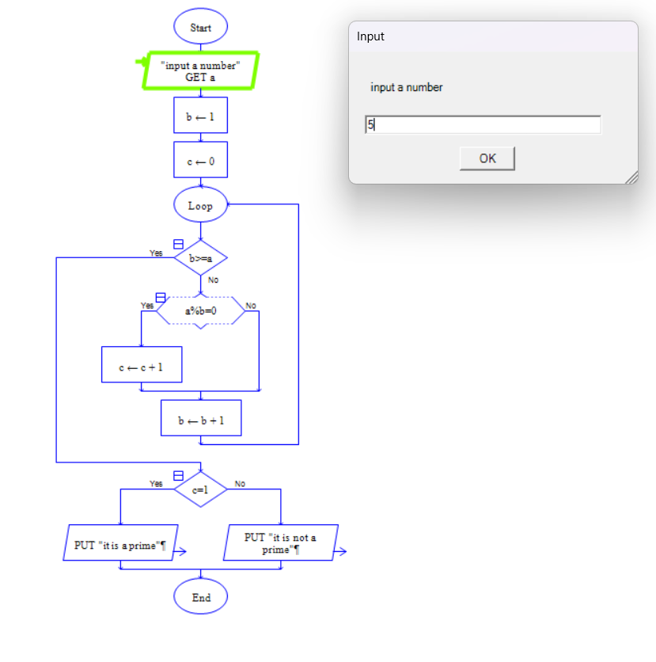



**2.Finding the factorial of the given number by the user.**

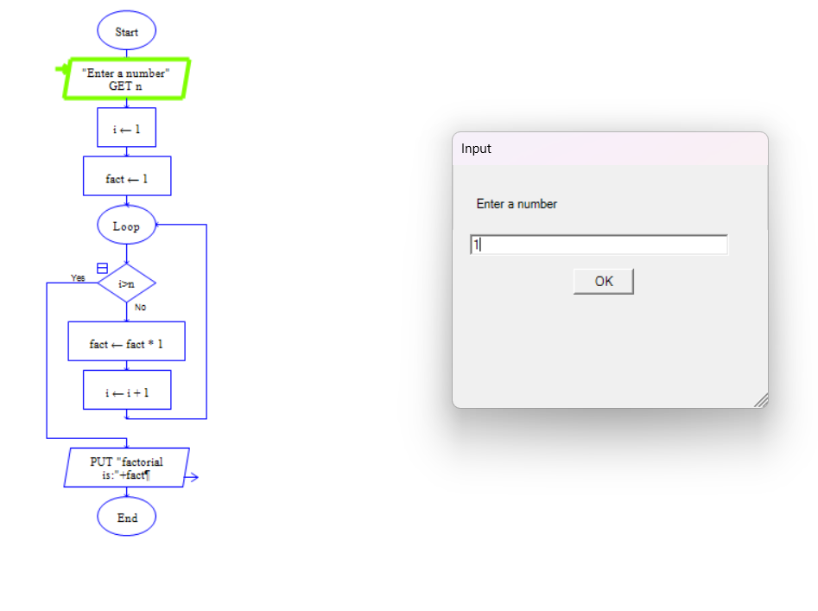



**3.Finding the Fibonacci series up to the given number by the user.**

